# Procedure for starting UCCSS

Open a command prompt and use the following command to start the MongoDB database server:

**mongod**

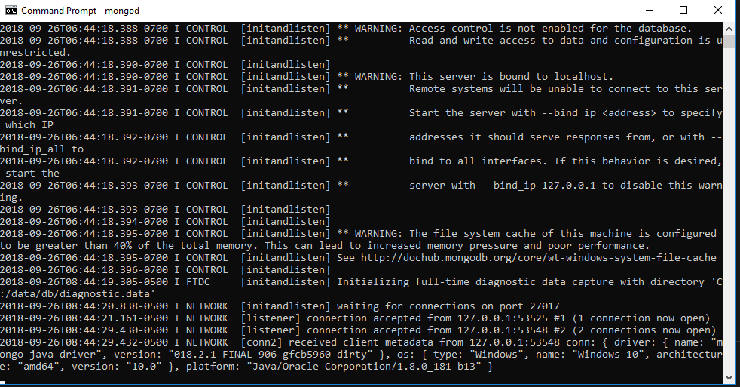

Once the database starts, open a second command prompt in the C:\UCCSS folder and use the following command to start the web site:

**pm2 start ecosystem.config.js --env production**

Test access to the site. If the web site doesn’t start properly with this command, use the following command to stop the web site:

**pm2 stop 1**

Then restart the web site in the same folder with this command:

**grunt production**